Obstacle Avoidance Car
-By Class 12th Science

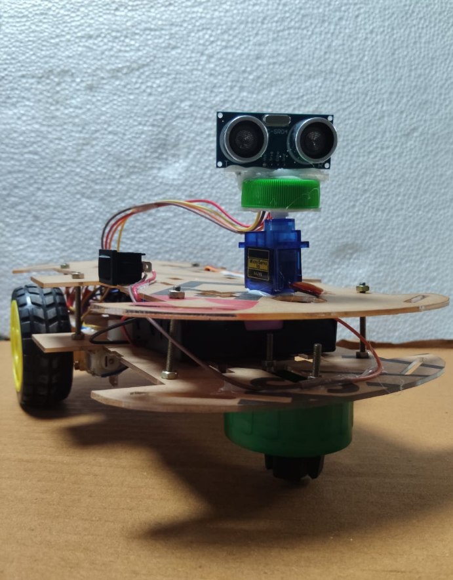

Working:
- Power: A 9V battery runs the Arduino and the motors.
- Ping: The sensor sends a silent 40 kHz pulse.
- Echo: The pulse bounces back, and the Arduino times it: distance = (time × speed of sound) ÷ 2.
- Clear (over 15 cm): Both motors drive forward.
- Obstacle (under 10 cm): Stop, scan right and left, reverse, turn left, then drive on and repeat.

Think about them:

- On a hot day, will the car misjudge a 50 cm obstacle as nearer or farther?
- The car reverses with no rear sensor. What could go wrong?
- Why is “turn for 500 ms” an unreliable way to turn a fixed angle?
- What happens if you add two more sensors and fire them together?
- Why does the code check distance > 0 as well as < 10?
- Why might the car miss an obstacle only 1 cm away?

